

NAME: Umashankar Kush
BRANCH: B. TECH (CSE)
UNIVERSITY: SAM GLOBAL UNIVERSITY

HR Analytics Dashboard using Power BI

Index
- Introduction
- Objective
- Dataset Information
- Tools Used
- Data Cleaning
- Dashboard Development
- Employee Retention Analysis
- Key Insights 9. Conclusion

1. Introduction

The HR Analytics Dashboard generated several important insights related to employee attrition, employee behavior, and workforce management. These insights help organizations understand the major reasons behind employee turnover and support better decision-making for improving employee retention and productivity.

The analysis performed using Power BI revealed patterns and trends in employee data through interactive visualizations and KPI metrics. The dashboard helped identify which factors have the greatest impact on employee attrition and retention within the organization.

2. Objective
The main objective of this project is to analyze employee data and identify the key factors responsible for employee attrition and retention in an organization using Power BI. The project aims to convert raw HR data into meaningful insights through interactive dashboards and visual reports that help management make better business decisions.

This HR Analytics Dashboard is designed to study employee behavior, work patterns, and job-related factors that influence employee satisfaction and turnover. By analyzing different employee attributes such as department, age group, education field, overtime, salary, and job role, the project helps organizations understand why employees leave the company and what steps can be taken to improve employee retention. schedules, and tracking event details seamlessly.

The specific objectives of this project are:

- To analyze the overall employee attrition rate in the organization.
- To identify departments with the highest employee turnover.
- To study the impact of overtime on employee attrition.
- To examine employee distribution based on gender, age group, and education field.
- To analyze job satisfaction levels and their relationship with employee retention.
- To understand how salary and years at the company affect attrition.
- To create an interactive and user-friendly HR Analytics Dashboard using Power BI.
- To provide data-driven insights that help HR managers improve employee engagement and retention strategies.

Another important objective of this project is to demonstrate the practical use of Business Intelligence and Data Analytics tools in solving real-world HR problems. The dashboard simplifies complex employee data into easy-to-understand visualizations, enabling faster analysis and decision-making.

This project also helps in improving analytical thinking, data visualization skills, and understanding of HR metrics using Power BI. Through this dashboard, organizations can monitor employee trends more effectively and take proactive measures to reduce attrition and improve workforce productivity.

3. Dataset Infromation
The dataset used in this project is an HR Employee Attrition Dataset, which contains detailed information about employees working in an organization. The dataset is mainly used to analyze employee retention, employee behavior, and the factors responsible for employee attrition. It includes both personal and professional employee-related information that helps in performing HR Analytics and generating meaningful business insights.
The dataset consists of approximately 1000 employee records and multiple columns containing employee details such as age, department, education field, salary, business travel, overtime status, job role, years at company, and attrition information. The data was imported into Power BI and processed using Power Query Editor before dashboard creation.
The dataset contains both categorical data and numerical data, which makes it suitable for visualization and analytical reporting. Different columns were used to create KPIs, charts, and interactive dashboards for analyzing employee retention trends.
The dataset was cleaned and transformed before analysis. During data preprocessing, unnecessary columns were removed, duplicate values were handled, text formatting was corrected, and invalid records were filtered out using Power Query Editor in Power BI.
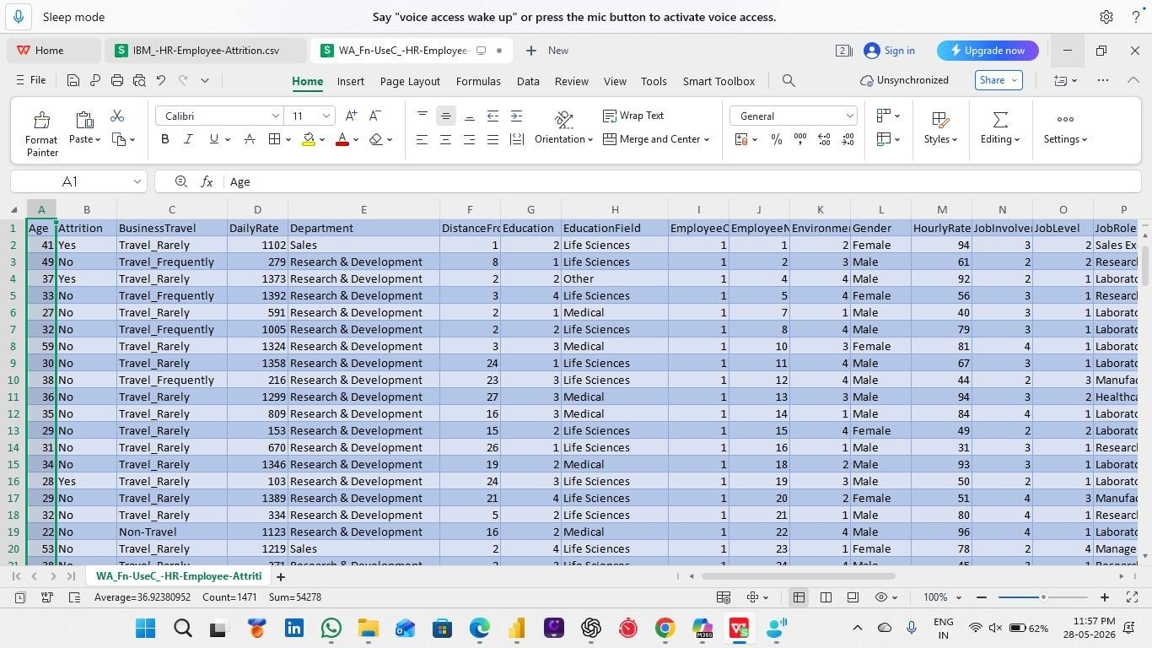
The dataset plays a very important role in this project because it provides the foundation for identifying employee retention patterns and understanding HR-related challenges. By analyzing this data, organizations can make informed decisions to improve employee satisfaction, reduce attrition, and increase workforce productivity.

4. Tool used
Various tools and technologies were used in this project to perform data cleaning, data analysis, visualization, and dashboard development. These tools helped in transforming raw HR data into meaningful insights and interactive reports. The combination of data processing and visualization tools made the project more effective, accurate, and user-friendly.

The main tool used in this project is Microsoft Power BI. Power BI is a Business Intelligence and Data Visualization tool developed by Microsoft that helps in creating interactive dashboards and analytical reports.
Power BI was used for:

- Importing the HR dataset
- Cleaning and transforming data
- Creating relationships between data fields
- Designing dashboards and reports
- Building charts, KPIs, and visualizations
- Performing employee attrition analysis
- Generating business insights

The dashboard created in Power BI includes multiple visual elements such as bar charts, pie charts, donut charts, line charts, and KPI cards. These visuals help users easily understand employee trends and retention patterns.

2. Power Query Editor
Power Query Editor* was used for data preprocessing and transformation before dashboard development. This tool helped improve the quality of the dataset by removing unnecessary and incorrect data.

Power Query was used for:
- Removing duplicate values
- Cleaning text data
- Filtering rows
- Removing unwanted columns
- Correcting data types
- Handling missing or invalid values
- Transforming raw data into structured format

Overall, the tools used in this project played an important role in successfully building an interactive HR Analytics Dashboard and performing employee retention analysis effectively.
Using Power Query improved the accuracy and reliability of the dashboard.

5. Data Cleaning

Data cleaning is one of the most important steps in any data analytics project because the quality of analysis depends on the quality of the dataset. In this HR Analytics Dashboard project, the raw employee dataset contained unnecessary columns, inconsistent text values, duplicate records, and formatting issues. Therefore, data cleaning was performed using Power Query Editor in Power BI before creating the dashboard and visualizations.

The main purpose of data cleaning was to improve data accuracy, remove errors, and prepare the dataset for proper analysis and reporting. A clean dataset helps generate reliable insights and improves dashboard performance.

• Data cleaning steps

- Unnecessary columns like EmployeeCount, StandardHours, etc. were removed
- Duplicate records were deleted
- Missing and null values were handled properly
- Text values were cleaned and standardized (Trim & Clean applied)
- Data types were corrected (Age, Salary, YearsAtCompany, etc.)
- Data was transformed using Power Query steps

Importance of Data Cleaning
Data cleaning played a major role in the success of this project because clean and structured data produces better visualizations and more accurate business insights. Without proper preprocessing, the dashboard could generate misleading results.
Benefits of data cleaning in this project:
- Improved data quality
- Accurate attrition analysis
- Better dashboard performance
- Reliable KPI calculations
- Easy visualization development * More meaningful HR insights
After completing the data cleaning process, the final dataset became ready for dashboard creation and employee retention analysis in Power BI.

Data Transformation in Power Query
Power Query Editor was used to apply multiple transformation steps for preparing the dataset.

The applied steps included:
- Promoted Headers
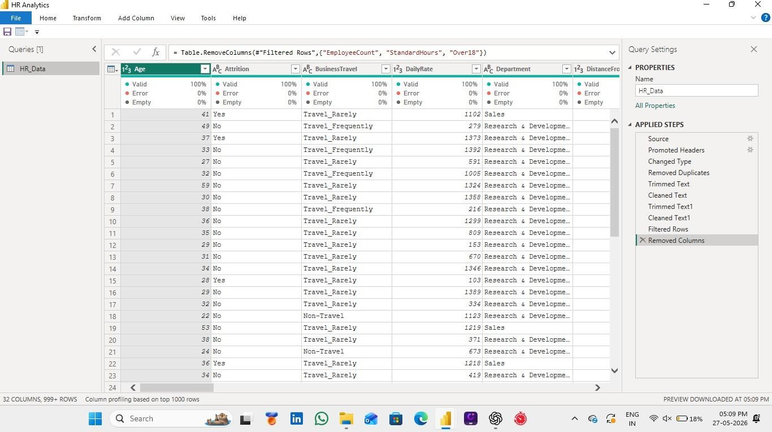
- Changed Type
- Removed Duplicates
- Trimmed Text
- Cleaned Text
- Filtered Rows
- Removed Columns
These transformation steps can also be seen in the Applied Steps section inside Power Query Editor.

6. Dashboard Development

Dashboard development is one of the most important phases of this HR Analytics project because it converts raw employee data into interactive visual reports and meaningful business insights. In this project, the dashboard was developed using Microsoft Power BI to analyze employee attrition, retention, job satisfaction, overtime, salary distribution, and department-wise employee performance.
The main objective of dashboard development was to create a user-friendly and interactive HR Analytics Dashboard that allows HR managers and decision-makers to easily understand employee trends and take data-driven actions for improving employee retention.

After completing the data cleaning and transformation process, the prepared dataset was loaded into Power BI for dashboard creation. Different visualizations, charts, KPIs, filters, and slicers were used to present employee information in a simple and understandable format.

Steps Followed
- Importing Dataset Cleaned HR data was imported into Power BI and data relationships were checked for accurate analysis.
- KPI Cards Key metrics such as Total Employees, Attrition Rate, Average Salary, Average Age, and Years at Company were displayed using KPI cards.

3. Visualizations
- Bar Charts: Department-wise attrition, job roles, salary analysis
- Pie/Donut Charts: Gender, attrition %, education field
- Line Charts: Attrition and employee trends over time
- Tables/Matrix: Detailed employee data
•
- Filters and Slicers Interactive filters like Department, Gender, Job Role, Education Field, and Overtime were added for dynamic analysis.
- Dashboard Design A clean and professional layout was created using proper colors, labels, alignment, and formatting.

- Retention Analysis A separate section was used to analyze factors affecting attrition such as age, salary, overtime, and job satisfaction.

Features
- Interactive dashboard with filters
- Real-time HR insights
- KPI-based summary view

Importance
This dashboard helps HR teams quickly understand employee trends, identify attrition reasons, and make data-driven decisions to improve retention and workforce planning.
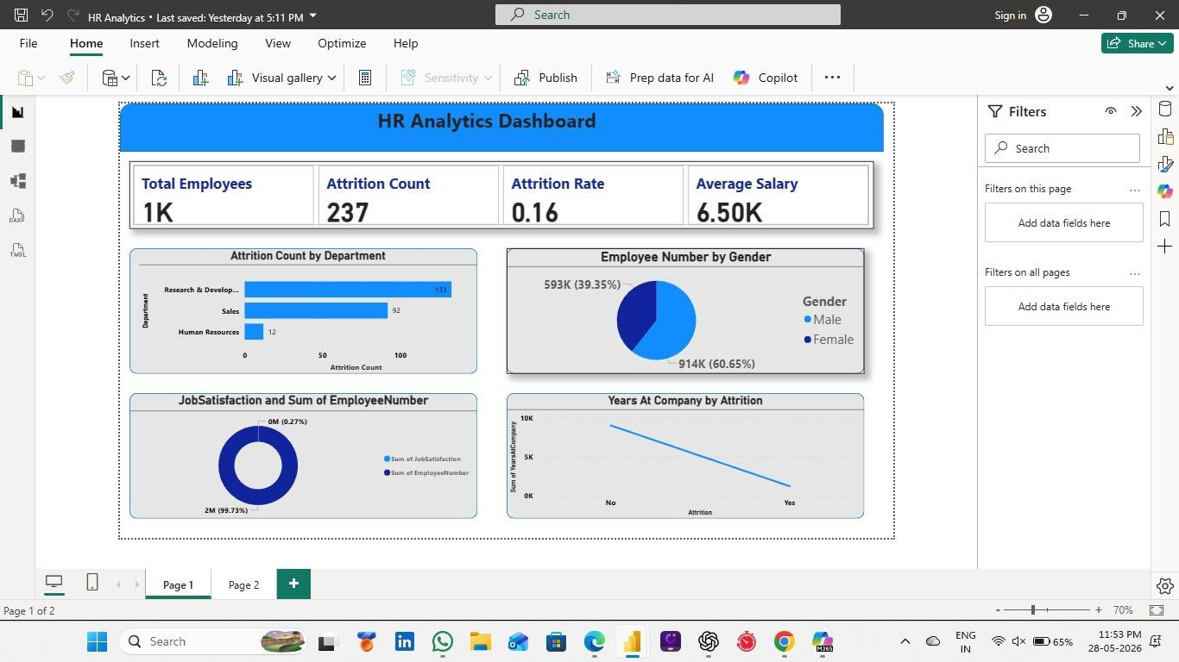

7. Employee Retention Analysis
Employee Retention Analysis is an important part of the HR Analytics Dashboard used to understand the reasons behind employee attrition and improve retention strategies. It helps HR teams identify key factors affecting employee turnover such as department, age, salary, overtime, job satisfaction, education, and years at the company.
The analysis was done using Power BI visualizations and KPIs to find patterns in employee behavior and highlight groups with higher attrition rates.

Key Analysis Areas

Department-wise Attrition
Some departments show higher attrition due to workload and working conditions, helping management focus on improvement areas.
Age Group Analysis ----- Younger employees tend to leave more often compared to experienced employees.
Overtime Impact ---- Employees working overtime frequently have higher attrition due to stress and poor work-life balance.

Salary Analysis-----Lower salary employees are more likely to leave, showing the importance of compensation policies.

Job Satisfaction ..... Low satisfaction levels are directly linked to higher employee turnover.

Education Field ...... Different education backgrounds show different attrition patterns.

Key Findings
- Overtime increases attrition
- Younger employees leave more frequently
- Low salary leads to higher turnover
- Job satisfaction strongly affects retention
- Certain departments have higher attrition
- New employees are less stable

Importance
This analysis helps organizations reduce attrition, improve employee satisfaction, and make better HR decisions using data-driven insights.

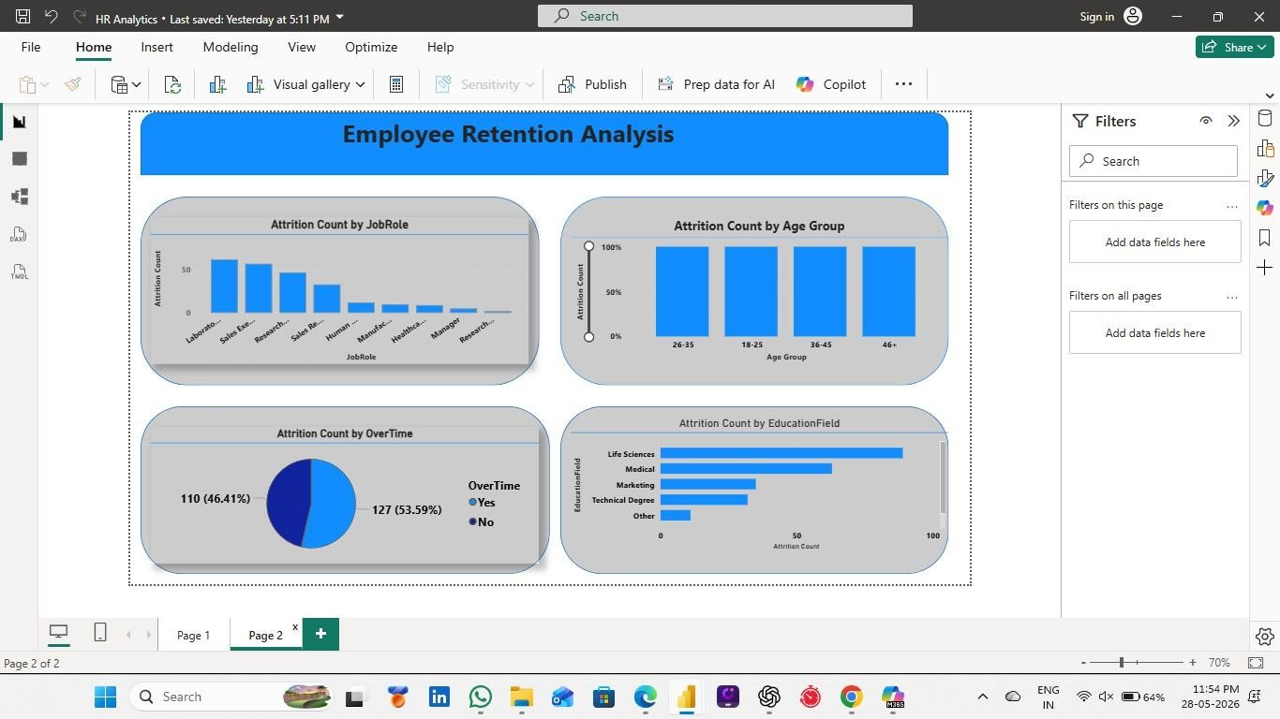
Overall, the Employee Retention Analysis performed in this project provides meaningful insights into employee behavior and helps organizations take data-driven decisions for improving employee retention and workforce efficiency.

8. Key Insights
The HR Analytics Dashboard generated several important insights related to employee attrition, employee behavior, and workforce management. These insights help organizations understand the major reasons behind employee turnover and support better decision-making for improving employee retention and productivity.

The analysis performed using Power BI revealed patterns and trends in employee data through interactive visualizations and KPI metrics. The dashboard helped identify which factors have the greatest impact on employee attrition and retention within the organization.

Major Insights Identified from the Dashboard

1. High Attrition in Certain Departments
The dashboard analysis showed that some departments experience higher employee attrition compared to others. Departments with heavy workload, pressure, and overtime had more employees leaving the company.

This insight indicates that organizations should focus more on improving work conditions, employee support, and workload management in high-attrition departments.

- Overtime Strongly Affects Employee Attrition

One of the most important findings of the project is that employees who work overtime regularly are more likely to leave the organization. Excessive overtime can increase stress levels and reduce work-life balance.

This insight suggests that companies should:

  - Reduce excessive workload

  - Maintain work-life balance

  - Improve employee wellness programs

  - Monitor overtime policies

Managing overtime effectively can help improve employee satisfaction and retention.
- Younger Employees Have Higher Turnover

The analysis showed that employees in younger age groups tend to leave the organization more frequently compared to older and experienced employees.
  - Possible reasons include:

  - Career growth expectations

  - Better opportunities in other companies

  - Lower job stability

  - Salary expectations

Organizations can improve retention among younger employees by providing better career development opportunities and employee engagement programs.

4. Salary Impacts Employee Retention

The dashboard revealed that employees with lower salaries show higher attrition rates compared to employees receiving higher compensation.
This insight highlights the importance of:

- Competitive salary packages
- Employee incentives
- Performance bonuses
- Financial benefits

9.Colclusion
The HR Analytics Dashboard project successfully demonstrates how data analysis and visualization techniques can be used to understand employee behavior, employee attrition, and workforce trends within an organization. The project was developed using Microsoft Power BI to transform raw HR data into meaningful insights through interactive dashboards and visual reports.

The main objective of this project was to identify the factors affecting employee retention and attrition. Through detailed analysis of employee data such as age, department, salary, overtime, job satisfaction, education field, and years at company, the dashboard provided valuable insights that can help organizations improve employee management and reduce turnover.
The project also highlights the importance of data cleaning and preprocessing before performing analysis. Using Power Query Editor, the dataset was cleaned, transformed, and prepared for accurate reporting and dashboard development. Different visualizations such as bar charts, pie charts, KPI cards, and line charts were created to simplify complex HR data into easy-to-understand graphical representations.
These insights can help HR departments and management teams make better business decisions and create effective employee retention strategies. Organizations can use this analysis to improve work-life balance, employee engagement, compensation policies, and workplace satisfaction.
This project also demonstrates the practical application of Business Intelligence and Data Analytics tools in solving real-world HR problems. The dashboard provides a modern and interactive way to analyze employee data and supports data-driven decision-making processes.

Overall, the HR Analytics Dashboard project was successful in achieving its objectives and providing meaningful business insights related to employee retention and workforce management. The project improved understanding of Power BI, data visualization, dashboard design, and HR Analytics concepts while demonstrating the importance of analytical thinking in business decision-making.

END
14

